BIT3208: ADVANCED WEB DESIGN AND DEVELOPMENT
Student details
Student Name: JESSICA ANNE
Admission Number: BSCCS/32081/2024
Course: Computer Science
Unit Code: BIT3208
Unit Name: Advanced Web Design and Development
Lecturer Name: Mr. Michael Nyoro
Semester/Academic Year: 2025/2026
Project details
Project Title: Urban-Furnish
Selected Technologies: PHP + MySQL
GitHub link
https://github.com/CybersecuritywithJess/BIT-3208-WEEK-6-CRUD

Table of Contents
Week 6: CRUD operations 2
Student Management System 2
Employee Management System 3
Library Management System 4

Week 6: CRUD operations

Student Management System
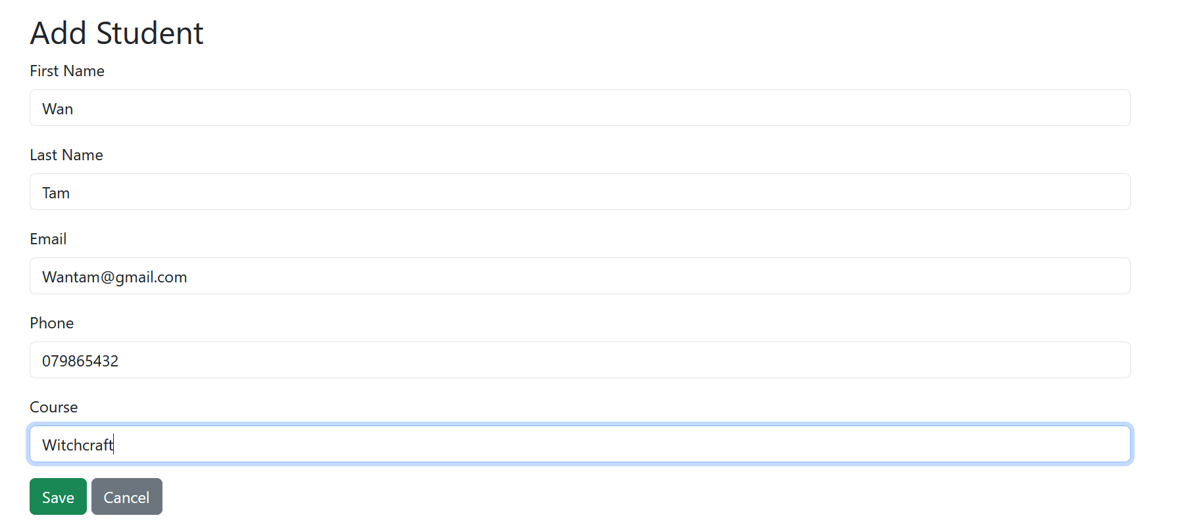
Figure 1: Create operation
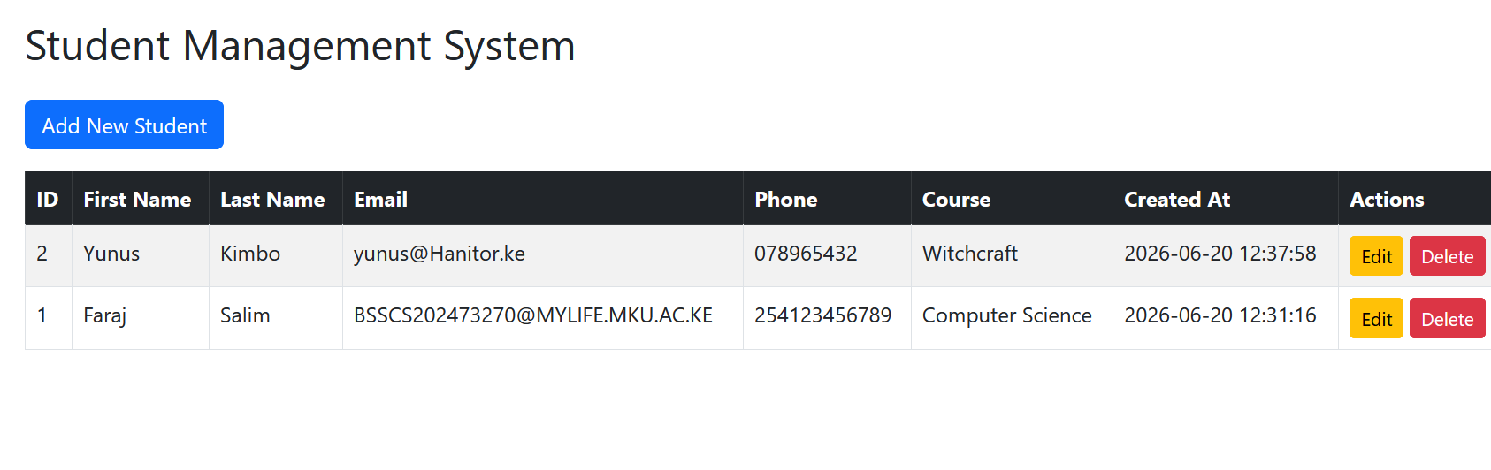
Figure 2: Read, Update and Delete Operations

Employee Management System
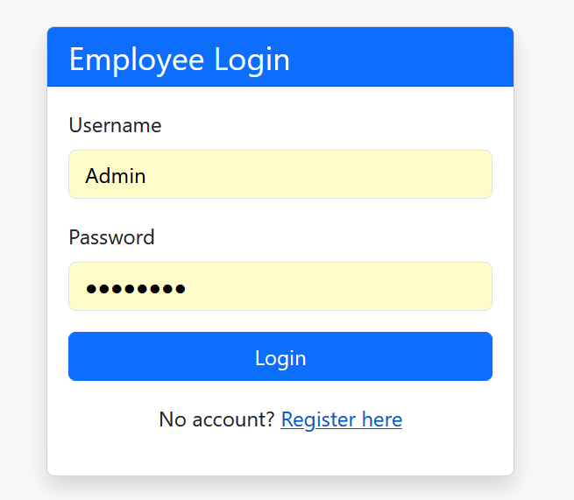
Figure 3: Admin login
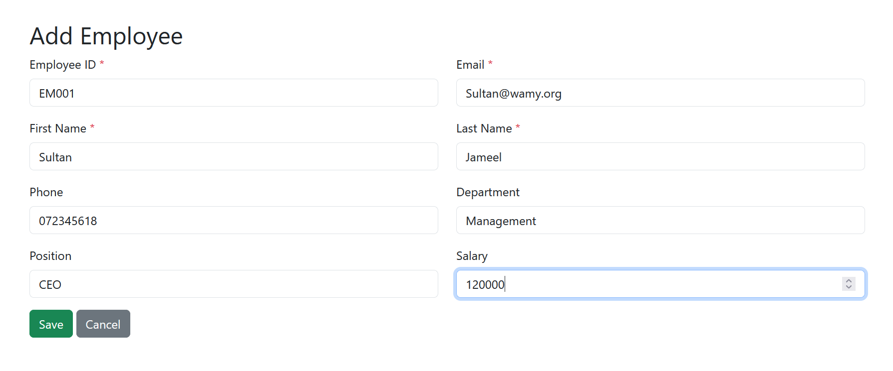
Figure 4: Employee Create Operation
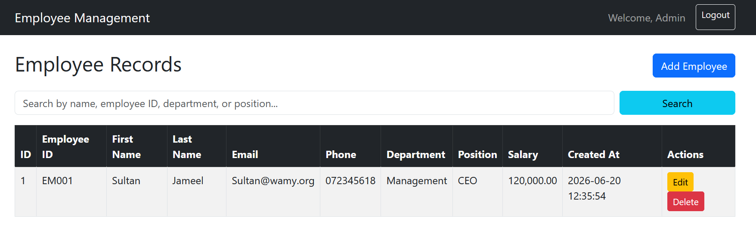
Figure 5: Employee Read, Update and Delete

Library Management System
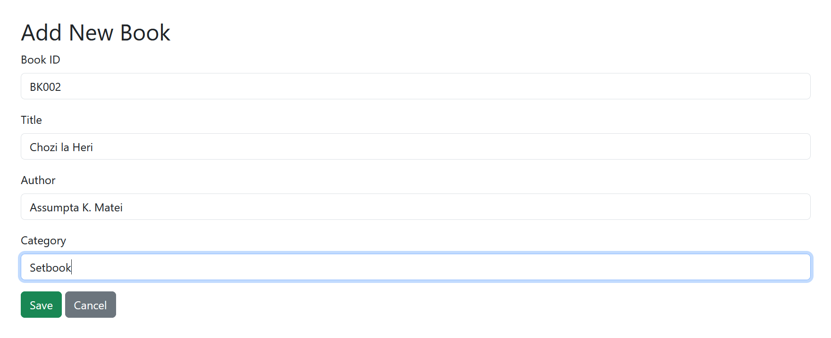
Figure 6: Book Create Operation
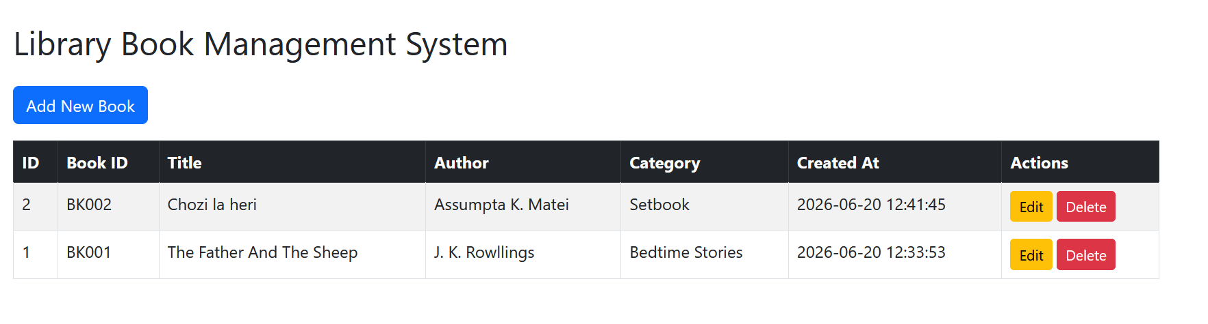
Figure 7: Book Read, Update and Delete

Weekly Reflections
- Databases are systems used to store, organize, and manage data for web applications so it can be easily accessed and updated.
- Static websites display the same fixed content to all users, while dynamic websites generate and display content in real time based on user interaction or data from a database.
- CRUD operations examples:
a) Create – Inserting a new user record into a database
b) Read – Retrieving a user’s profile information
c) Update – Modifying existing data such as a user’s email address
d) Delete – Removing a user record from the system
- PHP connects to MySQL databases using functions such as mysqli_connect() and SQL queries to perform operations like inserting, retrieving, updating, and deleting data.
- Input validation helps ensure that user input is correct, safe, and properly formatted, reducing errors and protecting the system from malicious data.
- One major risk of poor database design or weak security is SQL injection, which can allow attackers to manipulate or gain unauthorized access to data.

